*IP PROJECT*

*XPERT OS*

**

*P SAI AAKASH*

*BOARD ROLL NO*

*ACADEMIC YEAR - 2018 -19*

*APS BANGALORE*

***CERTIFICATE***

*This is to certify that Sai Aakash Pothepalli of class XII, Roll No. __________________________ has completed the informatics practices* *investigatory project entitled XPERT OS*

*The progress of the project has been continuously reported and has been in my knowledge consistently*

*External examiners Teacher in charge*

***ACKNOWLEDGEMENT***

*It would be my utmost pleasure to express my sincere thanks to my Informatics Practices teacher Mr. Ajit Sir in providing a helping hand in this project.*

*His valuable guidance, support and supervision all through this project are responsible for attaining its present form. I would also like to thank my parents as they encouraged me to put forward my project successfully.*

***Index***

|  |  |  |
| --- | --- | --- |
| *SL NO* | *TOPIC* | *PG NO* |
| *1* | *Introduction*  *And Software used* | *5* |
| *2* | *Database tables* | *6* |
| *3* | *Calculator* | *9* |
| *4* | *Contacts* | *19* |
| *5* | *BMI Calculator* | *26* |
| *6* | *Feedback* | *31* |
| *7* | *Conclusion* | *33* |
| *8* | *Bibliography* | *34* |

***Introduction***

*XPERT OS is an android look alike simulator which functions like an android phone. It has a user-friendly interface. It has applications such as- a advanced calculator, contacts, BMI calculator, feedback, launcher, and feedback.*

***Software Used***

***Front end***

* *NETBEANS IDE*

***Back end***

* *MYSQL*

***Database tables***

* *BMI*
* *Contacts*
* *Feedback*

***Contacts***

+--------+------------+--------------------------+

| Name | Ph no | e-mail

+--------+------------+--------------------------+

| Aakash | 9067474756 | p.saiaakash519@gmail.com

| Bhanu | 9023464757 | bhanu@gmail.com

| Arjun | 9123891294 | arjun@gmail.com

| Bharat | 9013481231 | bhanu13@gmail.com

| Aman | 9102371263 | aman@gmail.com

+--------+------------+--------------------------+

***BMI***

+----------+---------+----------+------------+

| NAME | HEIGHT WEIGHT | BMI |

+----------+---------+----------+-------------+

| Aakash | 1.67632 | 60.00000 | NULL |

| Arun | 1.79823 | 68.00000 | NULL |

| Atul | 1.98110 | 80.00000 | 20.38 |

| Aman | 1.70680 | 65.00000 | 22.31 |

| Bhanu | 1.65498 | 65.00000 | 23.73 |

| Mehul | 1.58488 | 50.00000 | 19.91 |

| Shashank | 1.70680 | 65.00000 | 22.31 |

| Bhalu | 1.43249 | 45.00000 | 21.93 |

| Sandeep| 1.82871 | 69.00000 | 20.63 |

| Tejas | 1.79823 | 65.00000 | 20.10 |

+----------+---------+----------+--------+

***Feedback***

+--------+--------------------------------------+

| NAME | FEEDBACK

+--------+--------------------------------------+

| Aakash | Owned it

| Bhanu | It is a great app

| Bushan | Nice , keep creating such apps

| Harjit | I liked it ,the calculator was good

| Arjun | I liked the contacts app

+--------+---------------------------------------+

***Applications***

1. ***CALCULATOR***
2. ***MAIN FRAME***

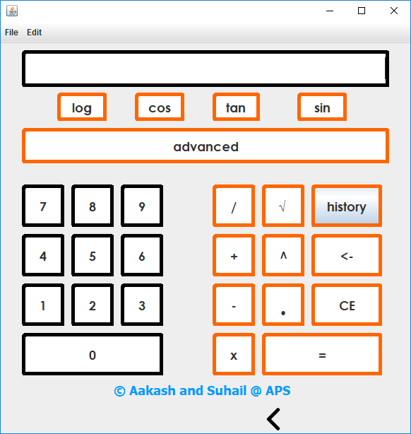

1. ***Features***

* *Addition*
* *Subtraction*
* *Division*
* *Multiplication*
* *Exponent*
* *Tan*
* *Cos*
* *Sin*
* *Log*
* *Root*
* *Clear*
* *Supports decimal values*
* *History*

1. ***Code***

***(a)Imports***

*import java.awt.Color;*

*import xpertos.Home;*

***(b) Global Variables Declared***

*int oper = 0;*

*String f="", y1="", t1="";*

*double b, f1,h*

*static String save1 = "";*

*boolean check=false;*

***(c) Number Buttons***

*1)*

*result.setText(result.getText() + "1");*

*save1 = save1 + "1";*

*2)*

*result.setText(result.getText() + "2");*

*save1 = save1 + "2";*

*3)*

*result.setText(result.getText() + "3");*

*save1 = save1 + "3";*

*4)*

*result.setText(result.getText() + "4");*

*save1 = save1 + “4";*

*5)*

*result.setText(result.getText() + "5");*

*save1 = save1 + "5";*

*6)*

*result.setText(result.getText() + "6");*

*save1 = save1 + "6";*

*7)*

*result.setText(result.getText() + "7");*

*save1 = save1 + "7";*

*8)*

*result.setText(result.getText() + "8");*

*save1 = save1 + "8";*

*9)*

*result.setText(result.getText() + "9");*

*save1 = save1 + "9";*

*0)*

*result.setText(result.getText() + "0”);*

*save1 = save1 + "0";*

***(d) Operators***

1. *Addition*

*oper();*

*save1 = save1 + " + ";*

*oper = 1;*

1. *Subtraction*

*oper();*

*save1 = save1 + " - ";*

*oper = 2;*

1. *multiplication*

*oper();*

*save1 = save1 + " x ";*

*oper = 3;*

1. *division*

*oper();*

*save1 = save1 + " / ";*

*oper = 4;*

1. *square root*

*f 1= Double.parseDouble (result.getText());*

*f1 = Math.pow(f1, 0.5);*

*result.setText(f1 + “”);*

*oper = 5;*

*6)power*

*f1 = Double.parseDouble(result.getText());*

*result.setText("");*

*oper = 6;*

*save1 += "^" ;*

*7) tan*

*save1 += "tan " ;*

*tan.setBackground(Color.green);*

*sin.setBackground(Color.white);*

*cos.setBackground(Color.white);*

*oper = 7;*

*8) sin*

*save1 += "sin " ;*

*tan.setBackground(Color.white);*

*sin.setBackground(Color.green);*

*cos.setBackground(Color.white);*

*oper = 8;*

*9) cos*

*save1 += "cos " ;*

*tan.setBackground(Color.white);*

*sin.setBackground(Color.white);*

*cos.setBackground(Color.green);*

*oper = 9;*

***(e) Calculation***

*switch (oper) {*

*case 0:*

*b = Double.parseDouble(result.getText());*

*result.setText("");*

*break;*

*case 1:*

*f1 = Double.parseDouble(result.getText());*

*b = b + f1;*

*result.setText("");*

*break;*

*case 2:*

*f1 = Double.parseDouble(result.getText());*

*b = b - f1;*

*result.setText("");*

*break;*

*case 3:*

*f = result.getText();*

*f1 = Double.parseDouble(result.getText());*

*b = b * f1;*

*result.setText("");*

*break;*

*case 4:*

*f1 = Double.parseDouble(result.getText());*

*b = b / f1;*

*result.setText("");*

*break;*

*case 5:*

*f1 = Math.pow(Double.parseDouble(result.getText()), 1 / 2);*

*result.setText("");*

1. ***Equal Button***

*if(result.getText().length()>0)*

*h = Double.parseDouble(result.getText());*

*switch (oper) {*

*case 1:*

*result.setText(String.valueOf(b + h));*

*save1 = save1 + " = " + " " + (b + h);*

*break;*

*case 0:*

*result.setText(t1);*

*break;*

*case 2:*

*result.setText(String.valueOf(b - h));*

*save1 = save1 + " = " + " " + (b - h);*

*break;*

*case 3:*

*result.setText(String.valueOf(b * h));*

*save1 = save1 + " = " + " " + (b * h);*

*break;*

*case 4:*

*result.setText(String.valueOf(b / h));*

*save1 = save1 + " = " + " " + (b / h);*

*break;*

*case 5:*

*h = Math.pow(h, 1 / 2);*

*result.setText(h + "");*

*save1 = save1 + " = " + " " + (h);*

*break;*

*case 6:*

*f = String.valueOf(Math.pow(f1, Double.parseDouble(result.getText())));*

*result.setText(f);*

*save1 = save1 + " = " + " " + (f);*

*break;*

*case 7:*

*f1 = Double.parseDouble(result.getText());*

*f1 = f1 * Math.PI / 180;*

*f1 = Math.tan(f1);*

*result.setText("" + f1);*

*save1 = save1 + " = " + " " + (f1);*

*break;*

*case 8:*

*f1 = Math.sin(Double.parseDouble(result.getText()) * Math.PI / 180);*

*result.setText("" + f1);*

*save1 = save1 + " = " + " " + (f1);*

*break;*

*case 9:*

*f1 = Math.cos(Double.parseDouble(result.getText()) * Math.PI / 180);*

*result.setText("" + f1);*

*save1 = save1 + " = " + " " + (f1);*

*break;*

*case 10:*

*f1 = Math.log(Double.parseDouble(result.getText()));*

*result.setText(f1 + "");*

*save1 = save1 + " = " + " " + (f1) ;*

*break;*

*}*

*if(result.getText().length()>0)*

*{*

*save1 = save1 + "\n";*

*oper = 0;*

*f = "";*

*y1 = "";*

*t1 = "";*

*b = 0;*

*f1 = 0;*

*h = 0;*

*}*

1. ***History***

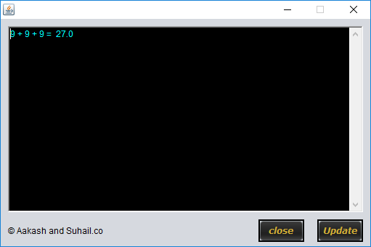

***(i ) Code***

*public HistoryCalc() {*

*initComponents();*

*ta.setText(aakashcalc11b.Calculator.save1);*

*String his;*

*}*

*private void jButton1ActionPerformed(java.awt.event.ActionEvent evt) {*

*ta.setText(aakashcalc11b.Calculator.save1);*

*}*

*private void closeActionPerformed(java.awt.event.ActionEvent evt) {*

*dispose();*

*new HistoryCalc().setVisible(false);:*

*}*

***2.CONTACTS***

***A) Main frame***

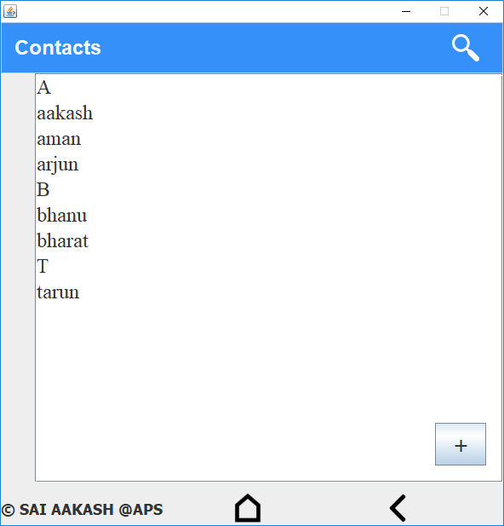

1. ***Code***
2. ***Imports***

*import java.sql.*;*

*import javax.swing.*;*

*import xpertos.Home;*

1. ***Global Variables Declared***

*static String SelectedName, SelectedPhNo, SelectedEmail;// variable for storing the selected name by the user*

*int b =int[] alphabets = new int[26] ; //stores 0 or 1 which informs that if a word with same starting alphabet has occurred*

*int k=0;// stores ascii value of selected name*

1. ***Load Contacts***

*DefaultListModel lb = (DefaultListModel) lb1.getModel();*

*for (int i = 0; i <26 ; i++) {//inserting all initial values of array as 0*

*alphabets[i] = 0 ;*

*}*

*try {*

*Class.forName("java.sql.Driver");*

*Connection con = DriverManager.getConnection("jdbc:mysql://localhost:3306/xpertos", "root", "");*

*Statement s = con.createStatement();*

*ResultSet r = s.executeQuery("select * from contacts order by name");*

*while (r.next()) {*

*String name = r.getString("name");*

*SelectedName = name;*

*k = (int)SelectedName.charAt(0);*

*Sorting();*

*lb.addElement(SelectedName);*

*}*

*lb1.setModel(lb);*

*for (int i = 0; i <26 ; i++) //clearing all values for further use in search*

*{alphabets[i] = 0 ;*

*}}*

*catch (Exception e) {*

*JOptionPane.showMessageDialog(this, e);*

*}*

1. ***Sorting***

*DefaultListModel lb = (DefaultListModel) lb1.getModel();*

*if (alphabets[k-97]==0)*

*{ lb.addElement(SelectedName.toUpperCase().subSequence(0, 1));*

*alphabets[k-97]=1 ;*

*}*

1. ***Search***

*DefaultListModel lb = (DefaultListModel) lb1.getModel();*

*lb.clear();*

*String SearchName = t1.getText();*

*String SearchCmd = "select * from contacts where name like '" + SearchName + "%' order by name;";*

*b=1;*

*try {*

*Class.forName("java.sql.Driver");*

*Connection con = DriverManager.getConnection("jdbc:mysql://localhost:3306/xpertos", "root", "");*

*Statement s = con.createStatement();*

*ResultSet r = s.executeQuery(SearchCmd);*

*while (r.next()) {*

*SelectedName = r.getString("name");*

*k = (int)SelectedName.charAt(0);*

*Sorting(); // groups the names by alphabets*

*lb.addElement(SelectedName);*

*lb1.setModel(lb);*

*}*

*}*

*catch (Exception e) {*

*JOptionPane.showMessageDialog(this, e);*

*}*

*for (int i = 0; i <25 ; i++) {//clearing all values for further use in search*

*alphabets[i] = 0 ;*

*}*

1. ***View Contact***

*SelectedName = lb1.getSelectedValue();*

*String sql = "select * from contacts where name ='" + SelectedName + "';";*

*try {*

*Class.forName("java.sql.Driver");*

*Connection con1 = DriverManager.getConnection("jdbc:mysql://localhost:3306/xpertos", "root", "");*

*Statement s1 = con1.createStatement();*

*ResultSet r1 = s1.executeQuery(sql);*

*while (r1.next()) {*

*SelectedPhNo = r1.getString("phno");*

*SelectedEmail = r1.getString("email");*

*}*

*} catch (Exception e) {*

*JOptionPane.showMessageDialog(this, e);*

*}*

*new ContactDetails().setVisible(true); dispose();*

***B) Contact Details***

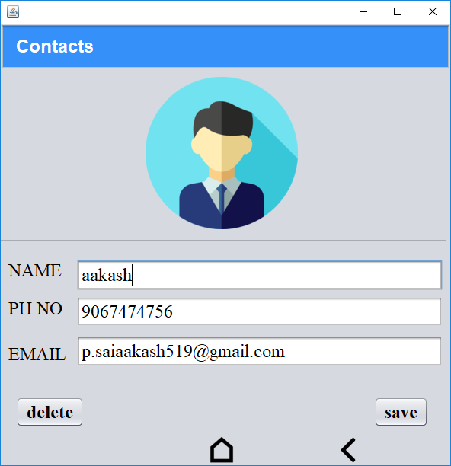

1. ***Code***
2. ***Save***

*public void saveC()*

*{*

*EditedName = t1.getText();*

*EditedPhNo = t2.getText();*

*EditedEmail = t3.getText();*

*String UpdateCmd = "update contacts set name ='"+EditedName +"' , phno ='"+EditedPhNo +"' ,email ='"+EditedEmail +"' where name ='"+SelectedName+"';";*

*try{*

*Class.forName("java.sql.Driver");*

*Connection con1 = DriverManager.getConnection("jdbc:mysql://localhost:3306/xpertos", "root","");*

*Statement s1 = con1.createStatement();*

*s1.executeUpdate(UpdateCmd);*

*JOptionPane.showMessageDialog(this,"Your edits have been saved :)" );*

*}*

*catch(Exception e)*

*{ JOptionPane.showMessageDialog(this, e);*

*}*

*}*

1. ***Delete***

*try{*

*Class.forName("java.sql.Driver");*

*Connection con1 = DriverManager.getConnection("jdbc:mysql://localhost:3306/xpertos", "root","");*

*Statement s1 = con1.createStatement();*

*EditedName= apps.Contacts.SelectedName;*

*s1.executeUpdate("delete from contacts where name = '"+EditedName+"';");*

*}*

*catch(Exception e)*

*{ JOptionPane.showMessageDialog(this, e);*

*}*

*JOptionPane.showMessageDialog(this, "contact has been deleted");*

*new Contacts().setVisible(true);*

*dispose();*

1. ***Create Contact***

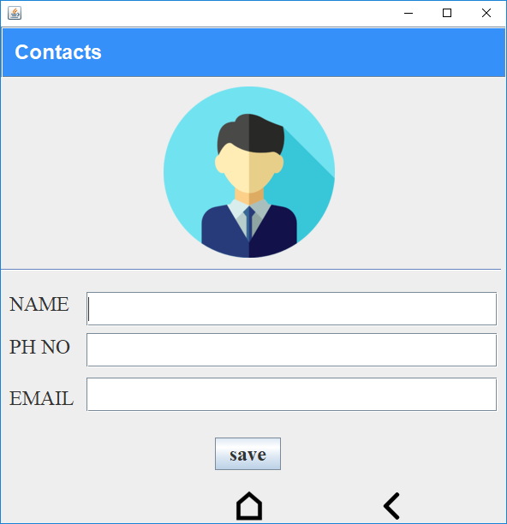

***(i) Code***

1. ***imports***

*import java.sql.*;*

*import javax.swing.*;*

*import xpertos.Home;*

1. ***save button***

*` public void saveC()*

*{*

*EditedName = t1.getText();*

*EditedPhNo = t2.getText();*

*EditedEmail = t3.getText();*

*String UpdateCmd = "insert into contacts set name ='"+EditedName +"' , phno ='"+EditedPhNo +"' ,email ='"+EditedEmail +"';";*

*try{*

*Class.forName("java.sql.Driver");*

*Connection con1 = DriverManager.getConnection("jdbc:mysql://localhost:3306/xpertos", "root","");*

*Statement s1 = con1.createStatement();*

*s1.executeUpdate(UpdateCmd);*

*}*

*catch(Exception e)*

*{ JOptionPane.showMessageDialog(this, e);*

*}*

*}*

***3.BMI calculator***

***A) Main Frame***

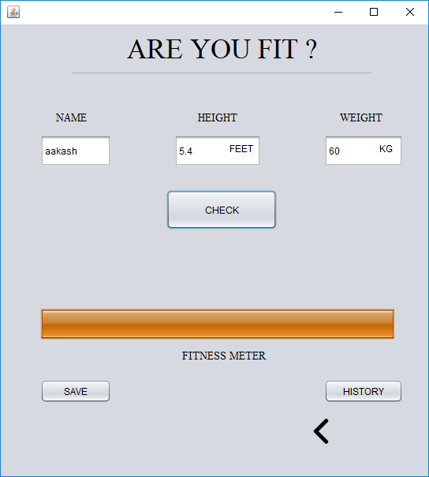

***(i) Code***

1. ***imports***

*import java.sql.Connection;*

*import java.sql.DriverManager;*

*import java.sql.Statement;*

*import javax.swing.JOptionPane;*

*import xpertos.Home;*

1. ***Check Button***

*height = Double.parseDouble(t2.getText())/3.281;*

*weight = Double.parseDouble(t3.getText());*

*name = t1.getText();*

*bmi = weight / Math.pow(height, 2);*

*double weight1;*

*if(bmi >=18.5 && bmi <= 24.9)*

*{*

*p1.setValue(100);*

*JOptionPane.showMessageDialog(this,"congrats you are healthy");*

*}*

*else if (bmi <18.5 )*

*{*

*p1.setValue(25);*

*weight1 = 21.5 * Math.pow(height,2 );*

*JOptionPane.showMessageDialog(this,"you have to increase your weight by "+ Math.round((weight1-weight))+ " KG");*

*}*

*else if (bmi >24.9 && bmi <= 29.9)*

*{*

*p1.setValue(75);*

*weight1 = 21.5 * Math.pow(height,2 );*

*JOptionPane.showMessageDialog(this,"You are over Healthy ! Need decrease your weight by "+ Math.round((weight-weight1))+ " KG");*

*}*

*else if(bmi > 29.9)*

*{*

*p1.setValue(25);*

*weight1 = 21.5 * Math.pow(height,2 );*

*JOptionPane.showMessageDialog(this,"you really have to decresse your weight by "+ Math.round((weight-weight1))+ " KG");*

*}*

1. ***Save button***

*if(name.equals("") | bmi==0.00 | height==0.00 | weight == 0.00 )*

*{*

*JOptionPane.showMessageDialog(this,"please enter your details" );*

*}*

*else{*

*String UpdateCmd = "insert into bmi set name ='"+name +"' , weight ='"+weight +"' ,height ='"+height +"', bmi ='"+bmi+"';";*

*try{*

*Class.forName("java.sql.Driver");*

*Connection con1 = DriverManager.getConnection("jdbc:mysql://localhost:3306/xpertos", "root","");*

*Statement s1 = con1.createStatement();*

*s1.executeUpdate(UpdateCmd);*

*JOptionPane.showMessageDialog(this,"your details havfe been saved" );*

*}*

*catch(Exception e)*

*{ JOptionPane.showMessageDialog(this, e);*

*}*

***B) History***

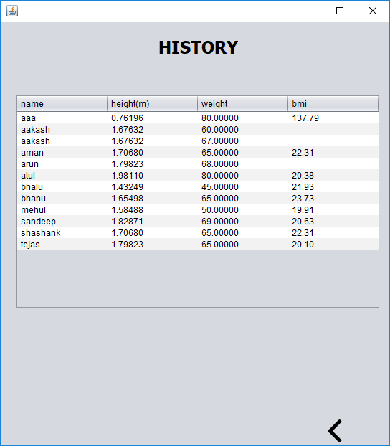

***(i) Code***

1. ***Imports***

*import java.sql.*;*

*import javax.swing.table.DefaultTableModel;*

1. ***Load***

*try {*

*DefaultTableModel jTable = (DefaultTableModel) jTable1.getModel();*

*Class.forName("java.sql.Driver");*

*Connection con = DriverManager.getConnection("jdbc:mysql://localhost:3306/xpertos", "root", "");*

*Statement s = con.createStatement();*

*ResultSet r = s.executeQuery("select * from bmi order by name");*

*while (r.next()) {*

*String name = r.getString("name");*

*String height = r.getString("height");*

*String weight = r.getString("weight");*

*String bmi = r.getString("bmi");*

*jTable.addRow(new Object[]{name,height,weight,bmi});*

*}*

*jTable1.setModel(jTable);*

*}*

*catch(Exception e)*

*{*

*JOptionPane.showMessageDialog(this, e);*

*}*

***4. Feedback***

***A) Main frame***

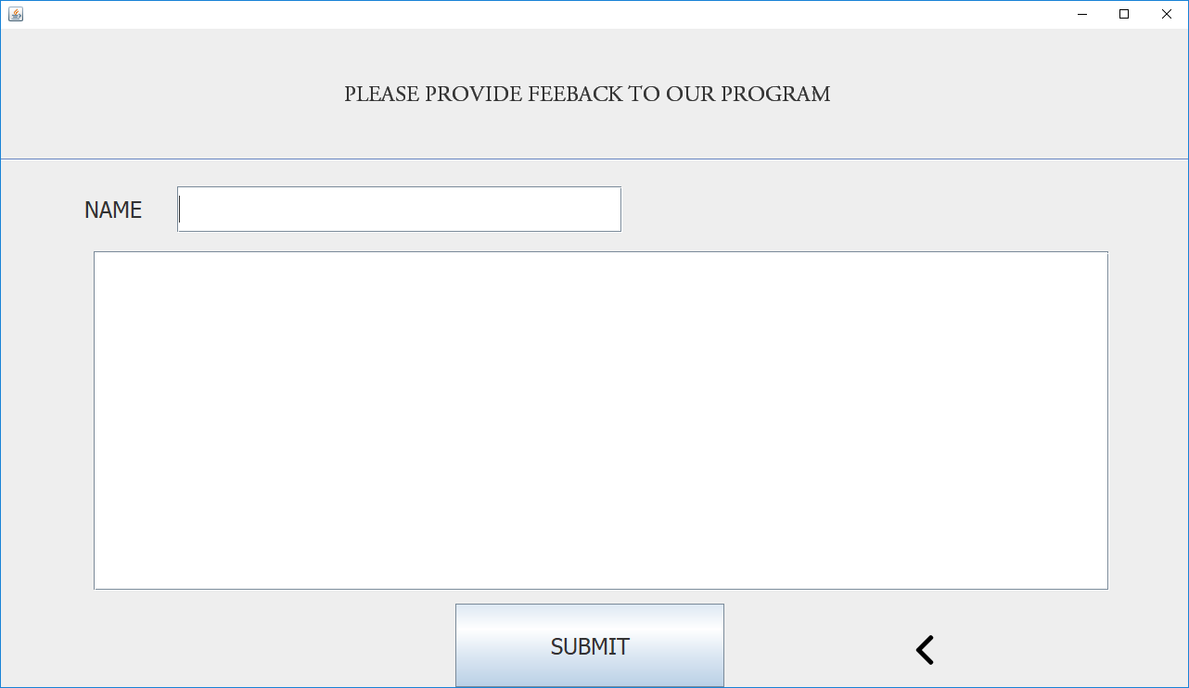

1. ***Code***
2. ***Imports***

*import java.sql.Connection;*

*import java.sql.*;*

*import javax.swing.JOptionPane;*

*import xpertos.Home;*

1. ***Submit***

*String Name = t1.getText();*

*String feedback = t2.getText();*

*String UpdateCmd = "insert into feedback set name ='"+Name +"' , feedback ='"+feedback +"';";*

*try{*

*Class.forName("java.sql.Driver");*

*Connection con1 = DriverManager.getConnection("jdbc:mysql://localhost:3306/xpertos", "root","");*

*Statement s1 = con1.createStatement();*

*s1.executeUpdate(UpdateCmd);*

*JOptionPane.showMessageDialog(this, "thank you for your feedback ");*

*}*

*catch(Exception e)*

*{ JOptionPane.showMessageDialog(this, e);*

*}*

***Conclusion***

*XPERT OS is an application software designed by me and it simulates an operating system which consists of Numerical Calculator, Contacts, BMI calculator, Feedback etc. The software uses a SQL database for storing the data and it operates on Java. The database has been integrated with java with the help of NetBeans IDE which uses JDBC to link both the platforms. Queries of the database has been designed in SQL.*

*This project has been successfully completed by me in all respects with the concepts taken from class 11 and 12.*

***Bibliography***

* *Class 12 IP textbook*
* *Class 11 IP textbook*
* *Quora.com*
* *Google.com*